Fams Conference Participant Feedback
Delegate feedback survey
All delegates were invited to share their experience at the conference, their reflections on the content, of the plenaries, the workshops, and any other aspects that they enjoyed, want to see more of or would have preferred to be different.
The intention of the conference was perhaps best met by the reflections of this participant:
“Never have I been to a conference so well put together, thought out and with intention. From the speakers to the workshops to the volunteers being attentive to everything. The Mc, Karen, was a great public speaker. She didn’t just talk, she communicated, and she inspired. Sarah Rowan’s session was a life changing experience. She made us laugh, cry, feel and most of all, act. Everyone from fams put their heart and soul to this event and it really showed. I left the conference feeling like I can take on the social injustices. Like I have become wiser and more compassionate. I can’t thank the fams fam enough!”
Participant Satisfaction:
Program content and structure
“Amazing speakers, very well organized and overall, a really inspiring and worthwhile conference”
“There was so much content and so much that was helpful. I wanted to hear more from so many people. Mary Jo McVey is inspirational and full of wisdom.”
“The conference was well coordinated and planned. Communication was great and the volunteers amazing. Material was relevant and topical interesting and credible presenters. I liked the format but would have enjoyed attending more info sessions because the subjects were so good.”
“A validation of the work we do”.
Survey results resulted in the following levels of satisfaction for the individual program sessions:
• Reimagining our sector – Very useful
• Amplifying client voices in evaluation – Very useful
• Widening the lens of child protection – Extremely useful
• Future-proofing the NGO sector – Very useful

Conference presentations and workshop themes in the graph below:

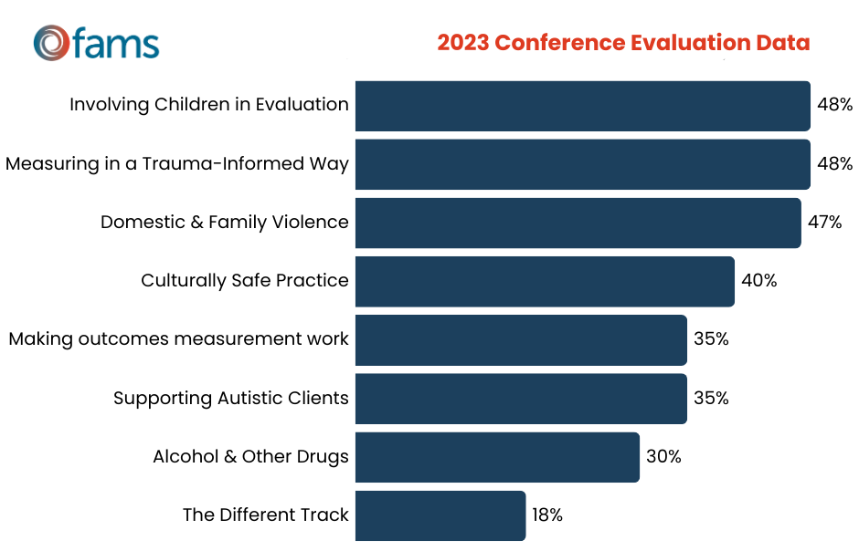

Operational and logistical aspects
“It was an extremely enjoyable day and so well organized very professional.”
“Perfect organization, substance and vibe.”
“It was great, well organised, really great presenters and the scholarships were great for people like me from the Mid North Coast for whom it would have been difficult to attend without one.”
Participant Suggestions for improvement:
Program content and structure
“More time for interaction and participation in the workshop sessions”
“I know time was limited, so either have 2 days to be able to unpack more of the topics as they were very brief. Lots of speakers all said very similar things about the systems being broken etc, which we all know, so it would be great to move into more deeper conversations than some very surface level items. It would have been great to have some actual discussions between the panel members and to get some more richer conversation happening from those varying perspectives.”
Operational and logistical aspects
“A bigger venue, if possible, for more space.”

